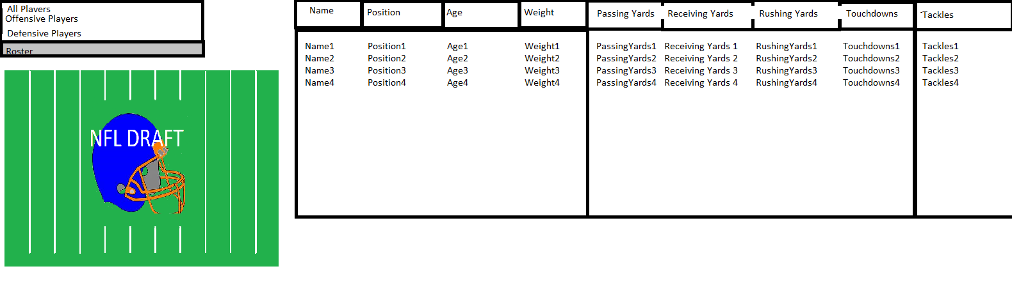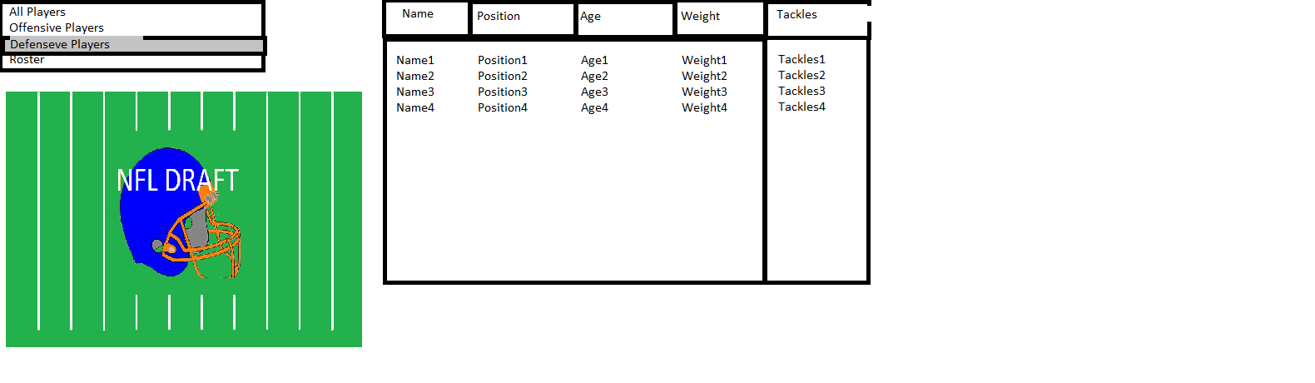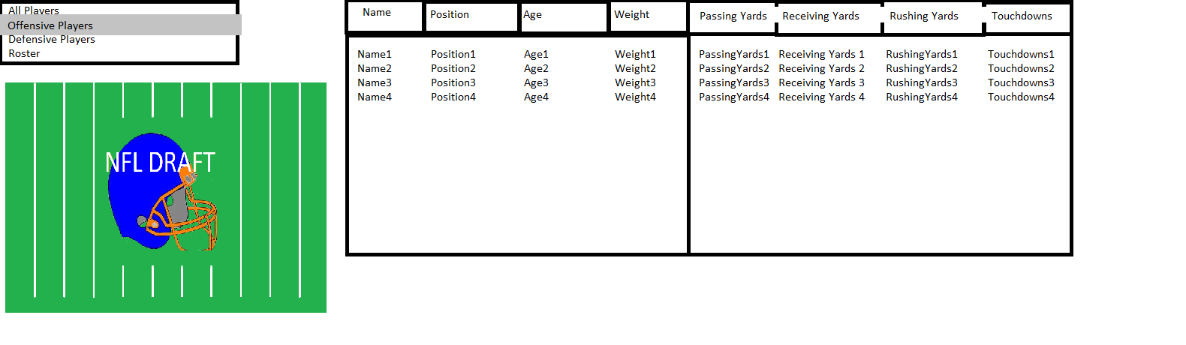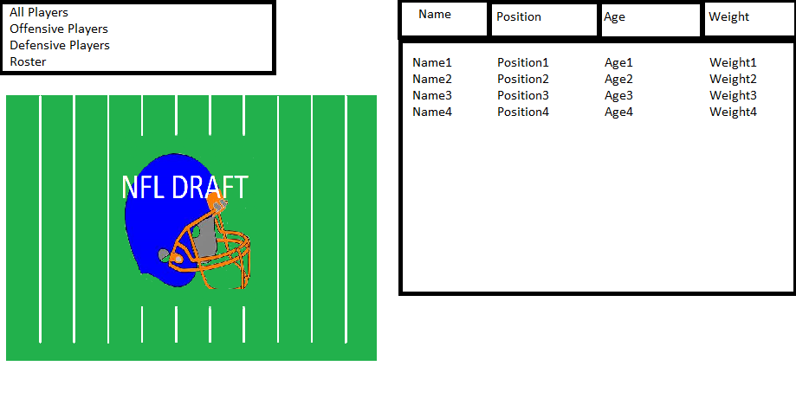

Scene for when Roster is selected

Scene for when Defensive Players is selected

Scene for when Offensive Players is selected

Startup Scene/ when All players Are clicked